Guidance

**1. Domain & Website Management**

[How to Add Your Own Domain to ERPNext](https://www.cloudclusters.io/docs/erpnext/New%20node1556121330.html)

[How to Manage DNS Records](https://www.cloudclusters.io/docs/erpnext/Managing%20DNS%20Zone1574903798.html)

[How to Install a Free Let’s Encrypt Certificate](https://www.cloudclusters.io/docs/erpnext/Installing%20a%20Free%20Let%27s%20Encrypt%20Certificate1607996520.html)

[How to Install a Customized SSL Certificate](https://www.cloudclusters.io/docs/erpnext/Installing%20a%20Customized%20SSL%20Certificate1607996569.html)

[How to Get the Credentials for ERPNext Admin Panel](https://www.cloudclusters.io/docs/erpnext/Resetting%20the%20Website%20Login%20Password1607996616.html)

[How to Enable CDN for Your Websites](https://www.cloudclusters.io/docs/erpnext/How%20to%20Enable%20CDN%20for%20Your%20Websites1642728726.html)

**2. Website File & Database Management**

[Introduction to SSH and SSH Command Usage](https://www.cloudclusters.io/docs/erpnext/SSH%20Introduction%20and%20Usage1607996637.html)

[How to Manage Your ERPNext via Shell/SSH](https://www.cloudclusters.io/docs/erpnext/How%20to%20Use%20Web%20Shell1592899499.html)

[How to Manage Website Files via File Manager](https://www.cloudclusters.io/docs/erpnext/Manage%20ERPNext1599121375.html)

[How to Transfer Data via FTP Account](https://www.cloudclusters.io/docs/erpnext/Transferring%20Data%20Using%20FTPS1607996718.html)

**3. ERPNext Application Management**

[How to Reboot ERPNext Application](https://www.cloudclusters.io/docs/erpnext/Rebooting%20ERPNext%20Service1607996762.html)

[How to Initialize ERPNext Application](https://www.cloudclusters.io/docs/erpnext/Re-initializing%20the%20ERPNext%20Application1607996799.html)

[How to Check Resource Usage on ERPNext packages](https://www.cloudclusters.io/docs/erpnext/Check%20the%20Resource%20Usage%20of%20Your%20ERPNext%20Package1607996830.html)

**4. Website Backup**

[How to Get a Backup of ERPNext](https://www.cloudclusters.io/docs/erpnext/Backup%20and%20Restoration1553233924.html)

**5. Website Restoration**

[How to Restore a Backup of ERPNext](https://www.cloudclusters.io/docs/erpnext/Restoring%20a%20System%20Backup1596177897.html)

**Add your Domain to ERPNext**

This article will show your how to add your domain to ERPNext in the control panel.

**1. Log in to the Client Panel**

Please [log in](https://clients.cloudclusters.io/) to the Control Panel with your credentials. Then locate your target deployment on the **Home** page or the **My Applications** page.

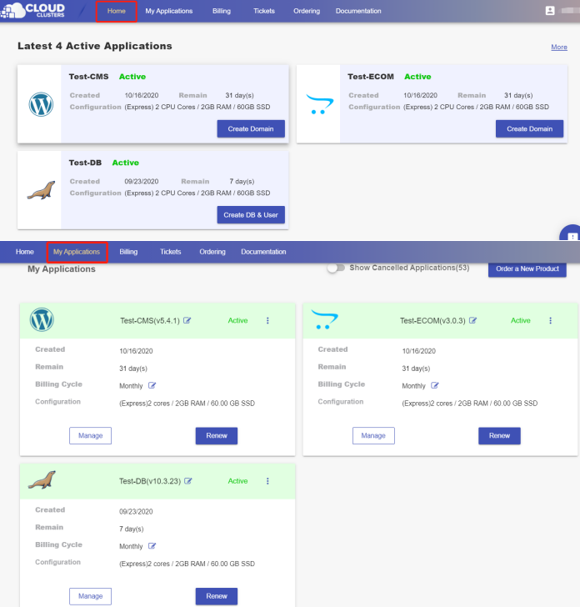

**2. Navigate to the "Site & SSL" page**

Click the "Manage" button on the **Home** page or the **My Applications** pgae, followed by the **“Site & SSL”** tab.

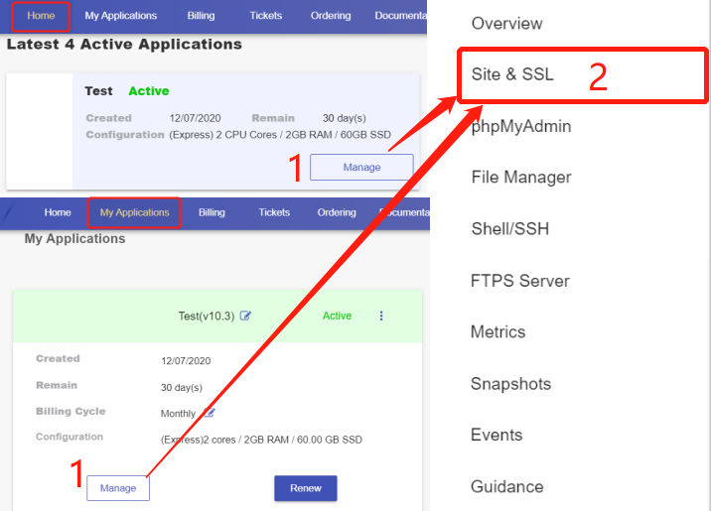

**3. Add your domain**

On this page, you can see that a default domain erpnext-XXXX-0.cloudclusters.net is configured for each newly-created ERPNext site. Locate the website and click “Create Domain” to add your customized domain.

* Step 1 Click “Create Domain” to add your customized domain.
* Step 2 Input the domain name. For example: testsite.com
* Step 3 Decide if you would like to use our nameservers or not.

**Yes:** If you use our nameservers, please set your domain’s nameservers to ns1.cloudclusters.net & ns2.cloudclusters.net.

**No:** If you prefer to use your own nameservers, you must make the "www" and "none" DNS A records of your domain point to the IP address we provide in the Control Panel.

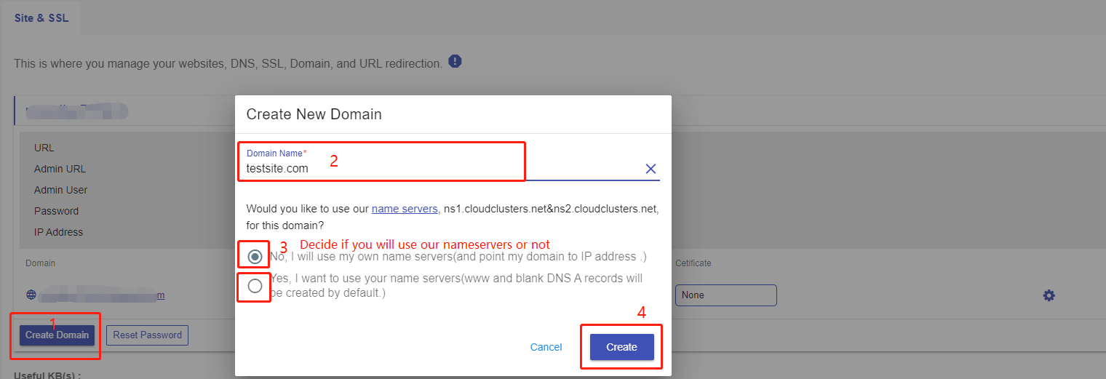

The IP can be viewed here.

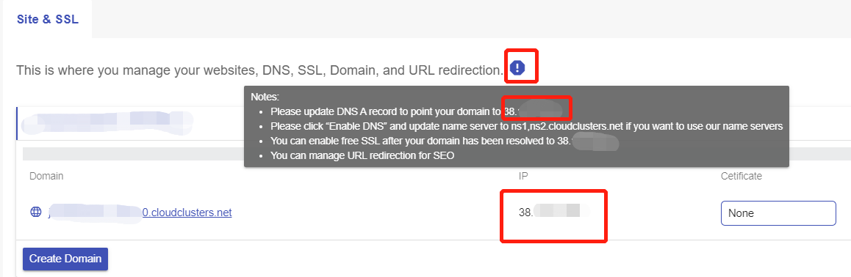

* Step 4 Click **Create** to add your domain.

**4. Check domain**

This is a feature to check your domain health. Click the **Check Domain** button for a domain. You will get the check result in a few seconds.

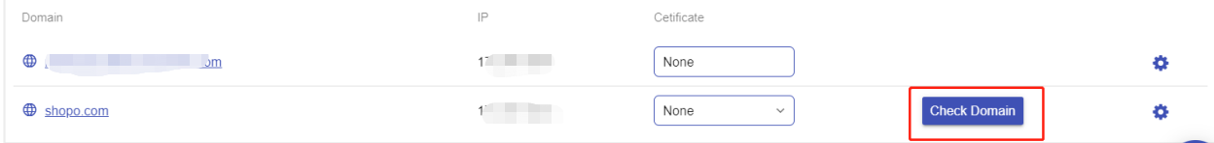

If there are any issues about your domain, please make sure the issues are addressed.

**5.Enable Free SSL**

The following steps are for installing free Let's Encrypt SSL to your domain. If your domain is not pointing to the IP address we provide, Free SSL cannot work.

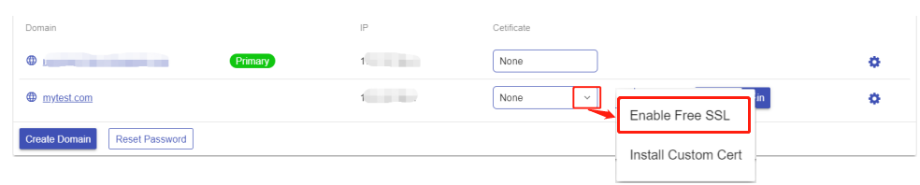

**6. Manage your ERPNext Site**

Now you can browse and manage your ERPNext site via browser. 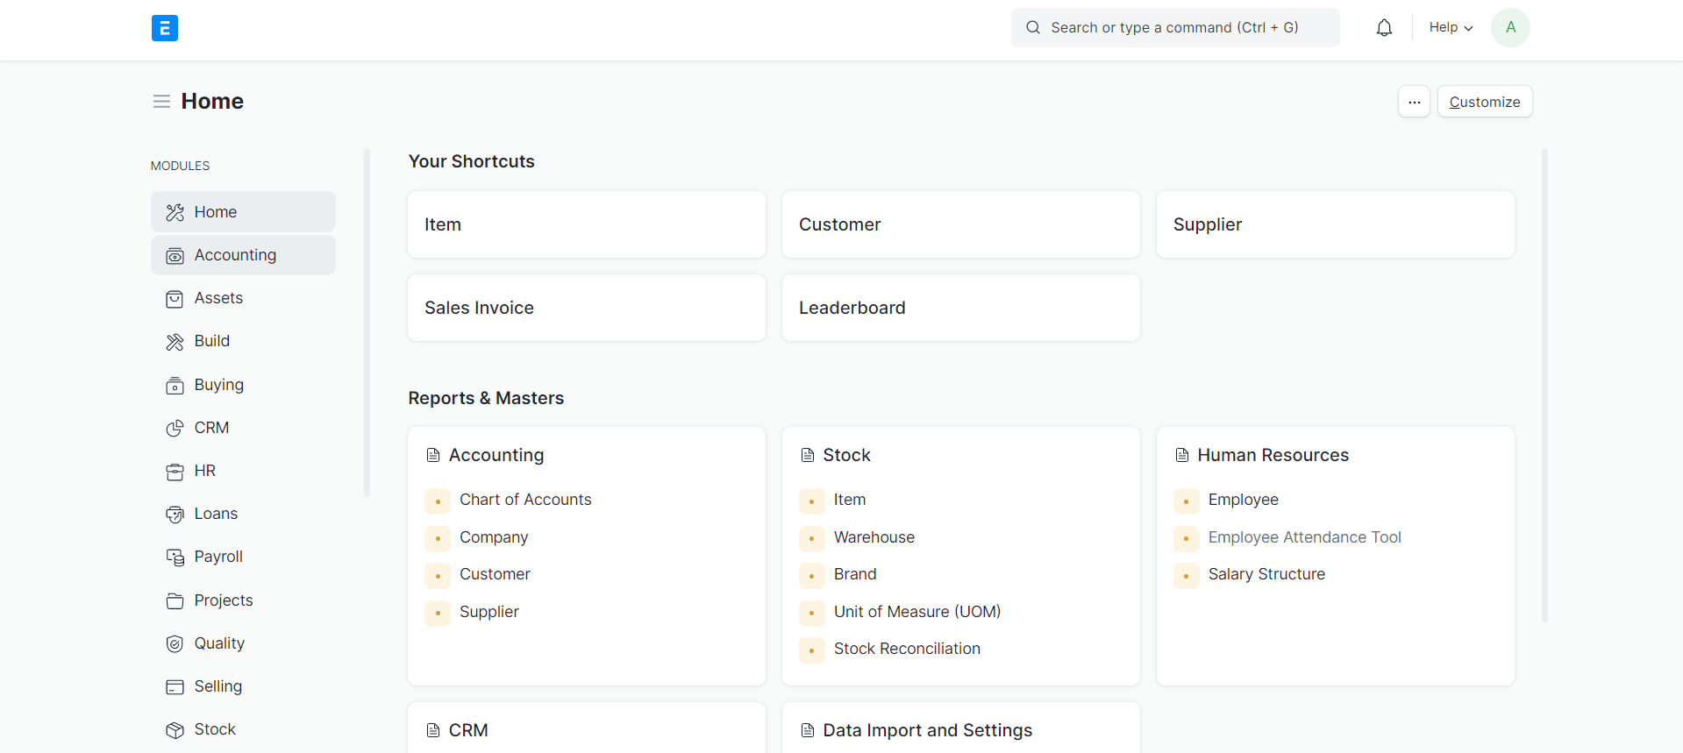

**Managing DNS Zone in Cloud Clusters**

Cloud Clusters offers name servers to manage DNS records for your domain. If you are new to this, please follow the steps below.

 Note:

* Before you start, make sure you have [created your customized domain](https://www.cloudclusters.io/docs/erpnext/New%20node1556121330.html).
* If you are using your own nameservers, you must make the "www" and blank DNS A records of your domain point to the IP address we provide in the Control Panel.

**Add your DNS records**

If you would like to change the your nameservers to ours, please click Enable DNS as illustarted in the following screenshot. In the meantime, **you'll need to update the nameservers at your current domain registrar to our nameservers**. The changes may take 2-24 hours to propagate.

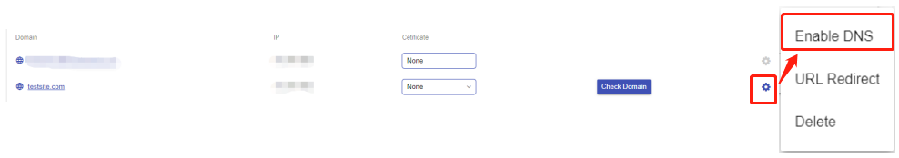

**1. Go to the "Manage DNS" page**

Click the icon at the end of the domain you just added, followed by clicking "Manage DNS". The **DNS Settings** dialog box will appear.

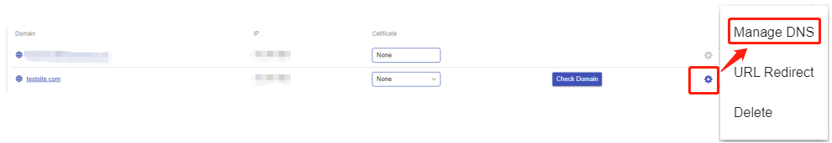

**2. Add DNS records**

Click Add to add DNS records. We support five DNS record types, including A record, MX record, NX record, TXT record, and CNAME record.

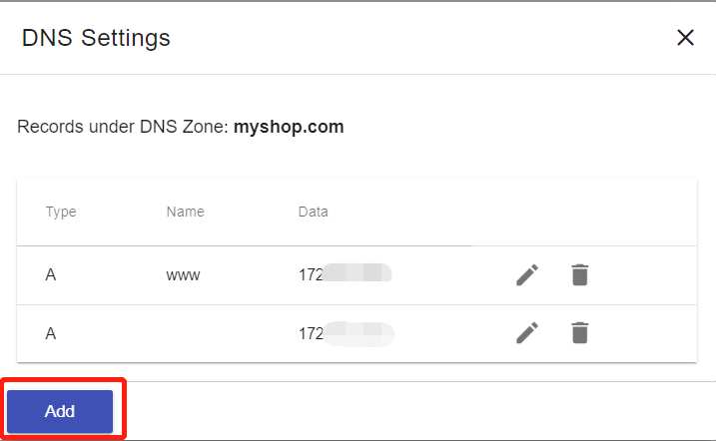

**Create an A record**

An A record maps a domain name to the IP address (Ipv4) of the computer hosting the domain. By default, The system has created a blank A record and a www A record.

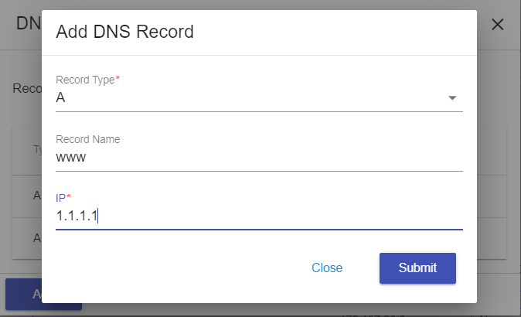

**Create an MX record**

MX records are used to specify the e-mail server(s) responsible for a domain name.

Before you create the MX record, an A record for the mail domain --"Record Name: mail; IP: Your mail IP" in this example -- should be created first.

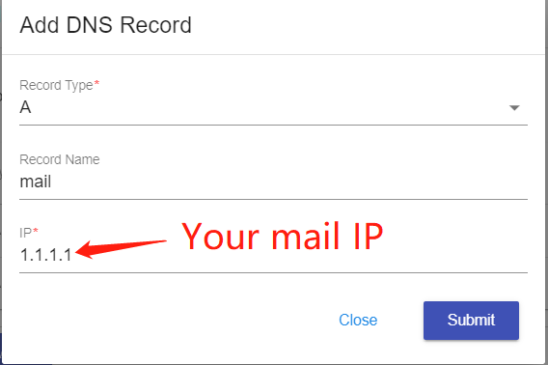

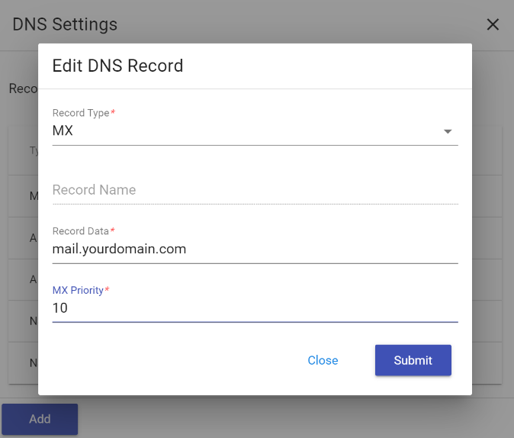

**Create an NS record**

NS records identify the DNS servers authoritative for a zone.

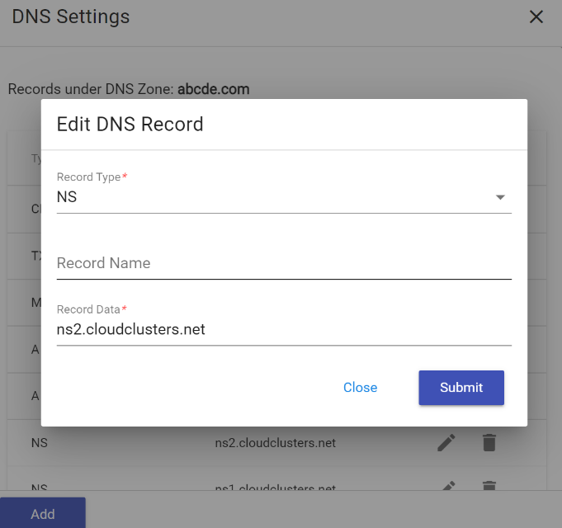

**Create a TXT record**

TXT records are used to provide the ability to associate arbitrary text with a host or other name

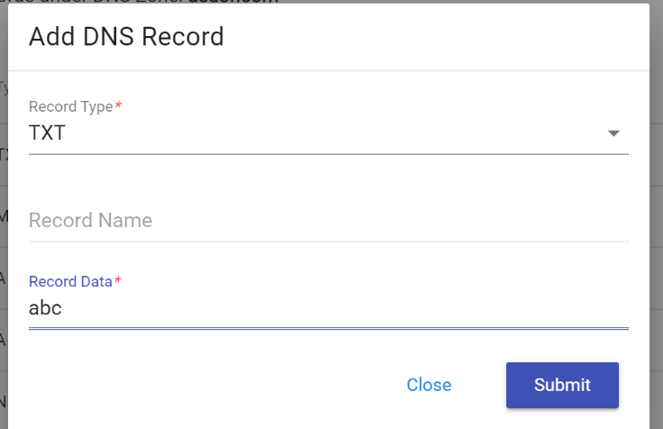

**Create a CNAME record**

CNAME records can be used to alias a hostname to another hostname.

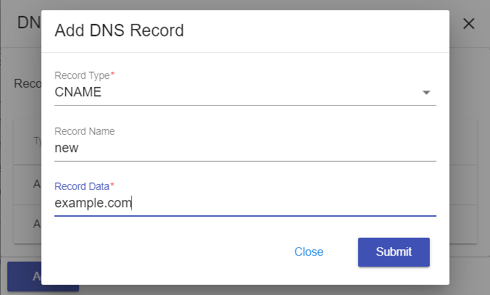

Once you've finished the settings, you can see all the records you created as the screenshot shows.

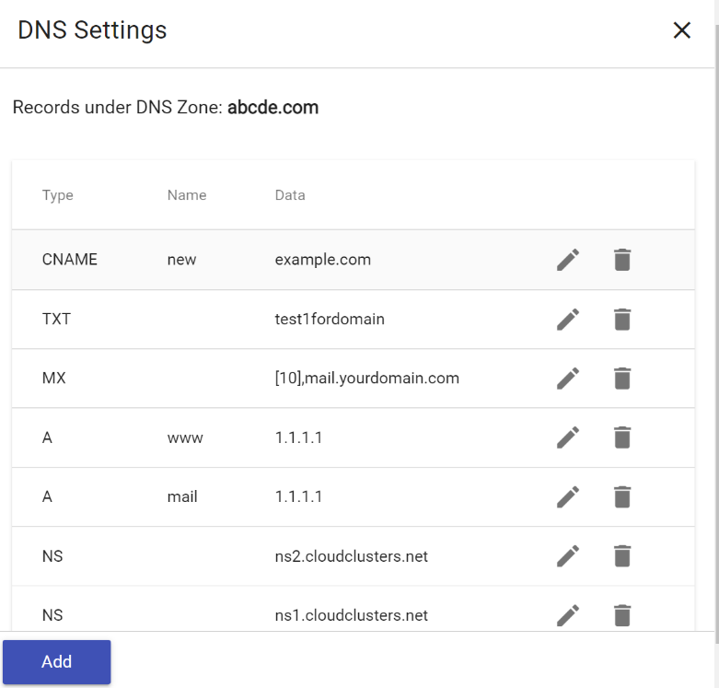

Should you have any question, please do not hesitate to contact us at support@cloudclustsers.io. We'd be happy to help.

**Installing a free SSL Certificate for a Domain**

This article is to illustrate the installation of Let's Encrypt certificate for a domain.

**1. Locate the target deployment**

Please [log in](https://clients.cloudclusters.io/) to the Control Panel with your credentials. And locate your target deployment on the **Home** page or the **My Applications** page.



**2. Navigate to the "Site & SSL" page**

Click the "Manage" button on the **Home** page or the **My Applications** pgae, followed by the **“Site & SSL”** tab. Then find the domain you would like to enable the SSL certificate for.



**3. Enable free SSL certificate**

The following steps are for installing free Let's Encrypt SSL to your domain. If your domain is not pointing to the IP address we provide, Free SSL cannot work.

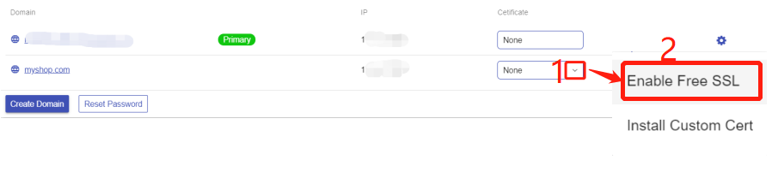

That's it! You've successfully installed Let's Encrypt certificate for your domain. If you would like to install a customized one, please refer to our guide on [Installing a Customized SSL Certificate](https://www.cloudclusters.io/docs/erpnext/Installing%20a%20Customized%20SSL%20Certificate1607996569.html)

**Installing a Customized SSL Certificate for a Domain**

This article is to illustrate the installation of a customized certificate for a domain.

**1. Log in to the Client Panel**

Please [log in](https://clients.cloudclusters.io/) to the Control Panel with your credentials. And locate your target deployment on the **Home** page or the **My Applications** page.



**2. Navigate to the "Site & SSL" page**

Click the "Manage" button on the **Home** page or the **My Applications** pgae, followed by the **“Site & SSL”** tab. Then find the domain you would like to enable the SSL certificate for.



**3. Install your SSL certificate**

Select "Install Custom Cert" from the drop-down box and then fill in your Certificate(CRT) and Private Key(KEY) into the blank. Your SSL certificate will be installed in one minute after you submit the request. You can also visit your domain to view your SSL by browser.

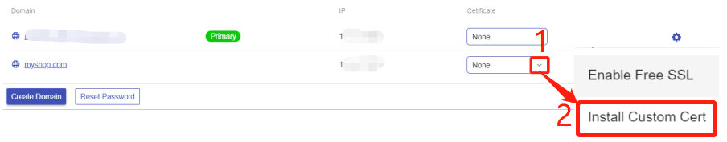

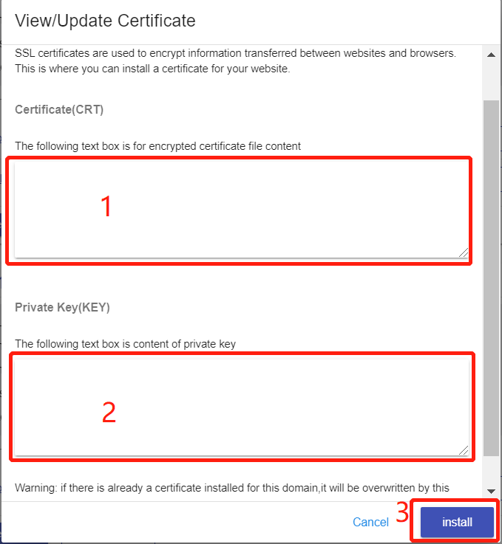

**How to Get Credentials for ERPNext Admin Panel**

The ERPNext admin panel is essentially the control panel for your entire ERPNext website. It's where you set up your ERPNext system. Once your ERPNext application is created, you can find the credentials for ERPNext Admin Panel in Cloud Clusters Control Panel.

**1. Create an ERPNext Application**

Please make sure you have [created your ERPNext application](https://clients.cloudclusters.io/ordering) on our platform.

**2. Get credentials for ERPNext Admin Area**

Go to the **Site & SSL** page in the Control Panel, you can see the ERPNext Admin URL and the credentials for it.



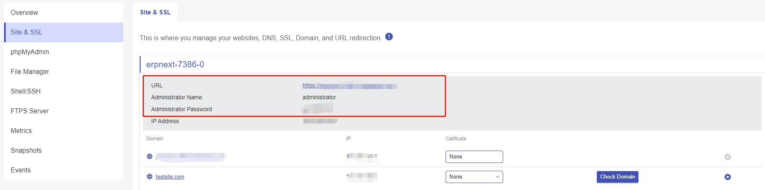

Click the Admin URL and input the username and password you just got. Then, click **Login**.

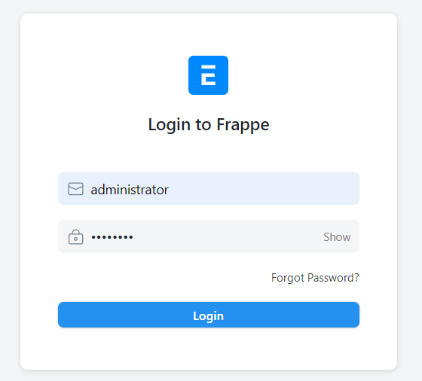

**3. Reset password**

Click "Reset Password" to reset the admin user password and save it.

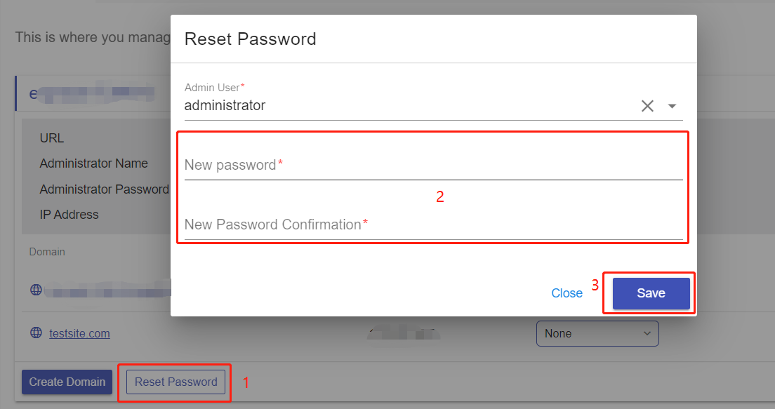

Once it finishes, you can log in to your ERPNext Admin Panel with the new credentials.

**2. Website File & Database Management**

**Introduction to SSH and SSH Command Usage**

The Shell / SSH service enables you to use Linux commands to manage your applications in the Control Panel. You can issue commands as if you are inside a container and perform local operations like monitoring, debugging, and using CLI commands specific to what is running in the container.

**The protocol is used in corporate networks for:**

* providing secure access for users and automated processes
* managing network infrastructure and other mission-critical system components.

**SSH Command Usage**

1. You should always run 'apt update' before any 'apt install' operations.
2. Softwares or packages installed via command "apt install" will be lost when the container is restarted.
3. The data and configuration files of your apps are stored in directories /cloudclusters.
4. Clients can manage web application services by supervisor CTL：
   * supervisorctl start/stop/restart apache
   * supervisorctl start/stop/restart mysql
   * supervisorctl start/stop/restart php-fpm

# Managing Your ERPNext Using Shell / SSH

The Shell / SSH service enables you to use Linux commands to manage your applications on the client panel. You can issue commands as if you are inside a container and perform local operations like monitoring, debugging, and using CLI commands specific to what is running in the container. This article will show you how to manage your ERPNext using shell / SSH.

**Note:** For security reasons, only the accounts have passed our verification will be granted permission to the Shell / SSH service. If you would like to enable it, please update your billing information. Our staff will finish verifying your information within 2 hours.

## 1. Locate the application

[Log in](https://clients.cloudclusters.io/) to the Client Panel and locate your target deployment on the **Home** page or the **My Applications** page.



## 2. Navigate to the "Shell / SSH" page

Click the "Manage" button on the **Home** page or the **My Applications** page. Then Click the "Shell / SSH" tab in the menu bar.

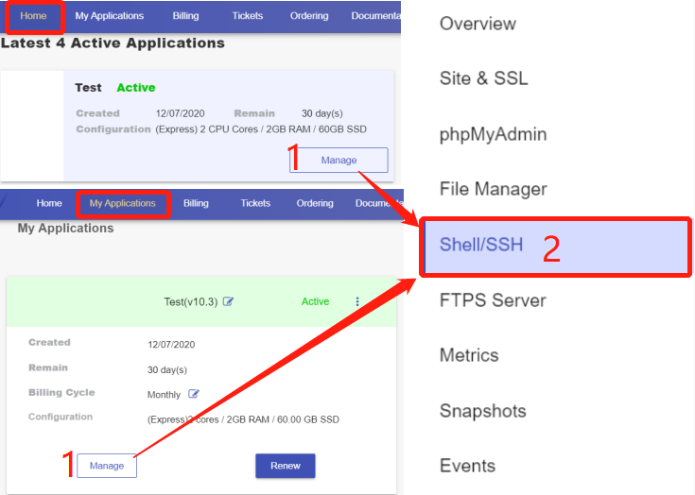

On the **Shell / SSH** page, you can see a "Connect" button, which is only open to the accounts that has passed our verification process for security reasons. To update your billing account information, please [log in](https://clients.cloudclusters.io/) to the client panel.

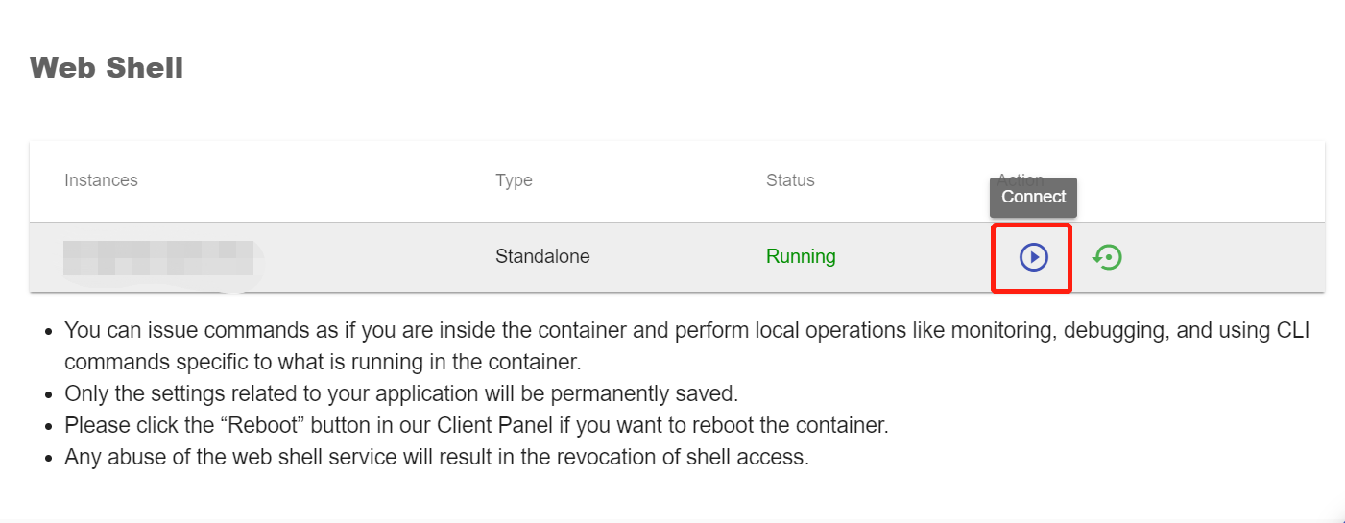

Click the Connect button to initiate a shell session. You can issue commands in it.

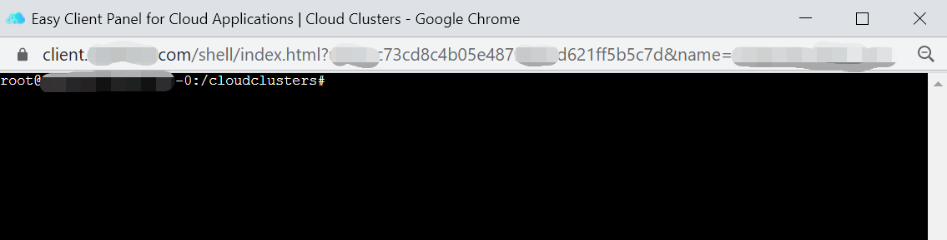

**Please note:**

1. You should always run 'apt update' before any 'apt install' operations.
2. Softwares or packages installed via command "apt install" will be lost when the container is restarted.
3. The data and configuration files of your apps are stored in directories /cloudclusters.
4. Clients can manage web application services by supervisor CTL：
   * supervisorctl start/stop/restart apache
   * supervisorctl start/stop/restart mysql
   * supervisorctl start/stop/restart php-fpm

**How to Use File Manager to Manage Website Files**

We provide a File Manager feature in the Client Panel so that web files in our cloud platform can be easily downloaded, uploaded, and deleted.

**1. Locate the target application**

Log in to the Control Panel and Locate your target deployment on the **Home** page or the **My Applications** page.



Go to the **File Manager** page by clicking the "Manage" button on the **Home** page or the **My Applications** page.

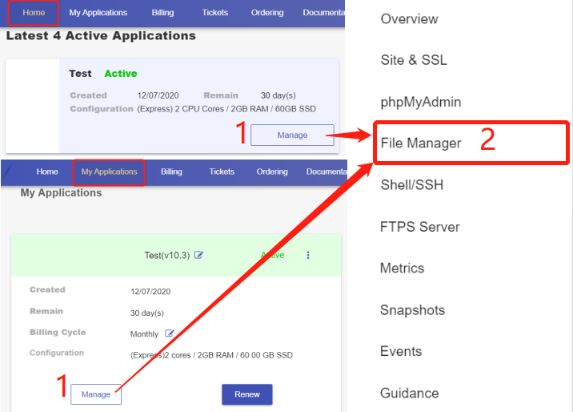

**2. Understand buttons in the File Manager section**

At the upper right corner of the File Manager, you will see a group of buttons.

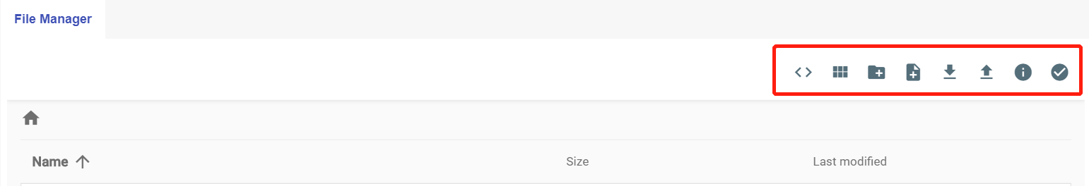

Let’s quickly browse each button from left to right:

* Toggle shell – It executes "unzip XXXXXX.zip" in the shell or allows you to enter other queries.
* Switch view – There are two views for switching.
* New File – It allows you to create a file from a folder.
* New Folder – It lets you create a new directory.
* Upload– It opens a pop-up window that directs you to select a new file to upload.
* Download – It gives the options for downloading the files.
* Info – It shows file information.
* Select Multiple – It allows you to choose multiple items.

**3. Make changes to a selected file or folder**

The context menu will be activated once a specific file or directory is selected.

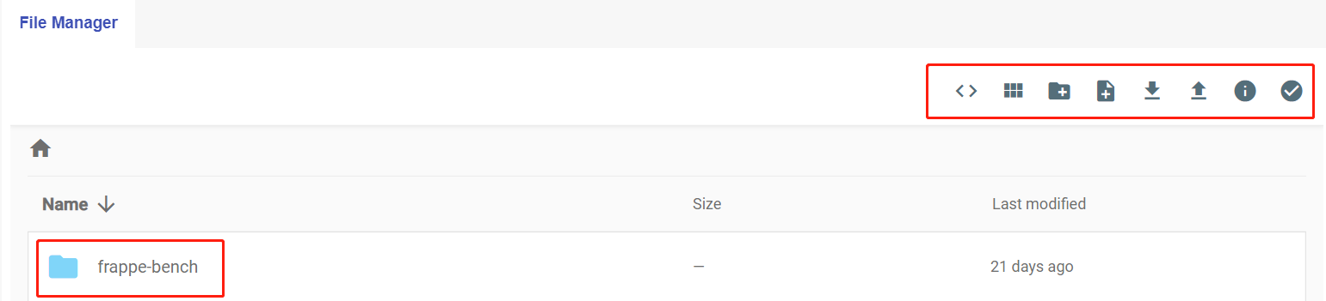

Let's browse each button from left to right.

* Rename – It is for editing the name of a file/ folder.
* Copy – The main function of “Copy” is to duplicate a file or folder to the same or different location.
* Move – It allows user(s) to transfer a selected file or folder to another directory.
* Delete –It permits user(s) to permanently erase a selected file or folder.

**Managing Database Using phpMyAdmin**

phpMyAdmin is a web-based tool for administering MariaDB and MySQL. ERPNext adopts the MariaDB database, so you can use phpMyAdmin to manage it.

**1. Locate your target deployment**

Log in to the Control Panel and locate your target deployment on the **Home** page or the **My Applications** page.

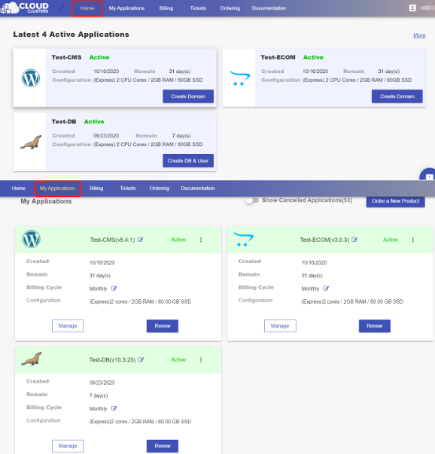

**2. Navigate to the “phpMyAdmin” page**

Click the "Manage" button on the **Home** page or the **My Applications** page to go to the **phpMyAdmin** page.

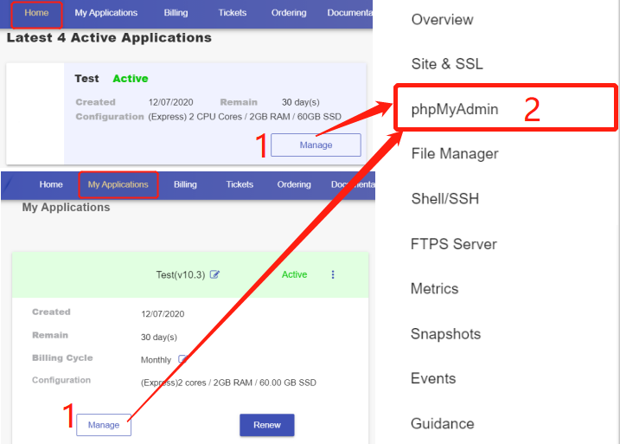

**3. Access phpMyAdmin**

Click “Launch” to go to the login interface of phpMyAdmin.

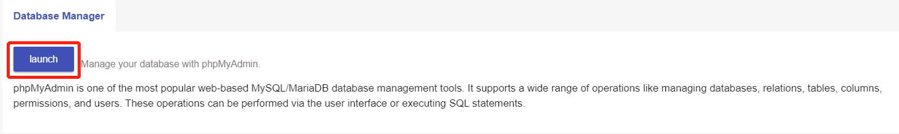

On the phpMyAdmin interface, you will see the database of your Magento on the left panel. Click on the database you want to manage.

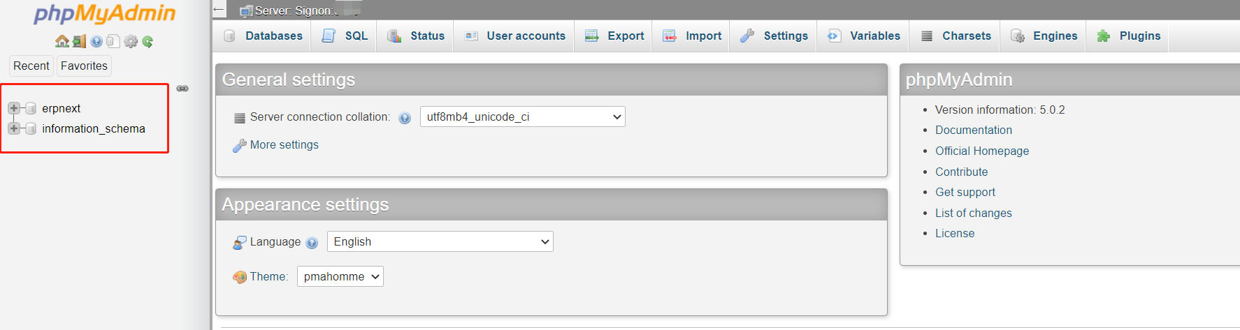

On this new page, you will see a list of the database tables, the allowed actions with them, the number of the records, the storage engine, the collation,etc.

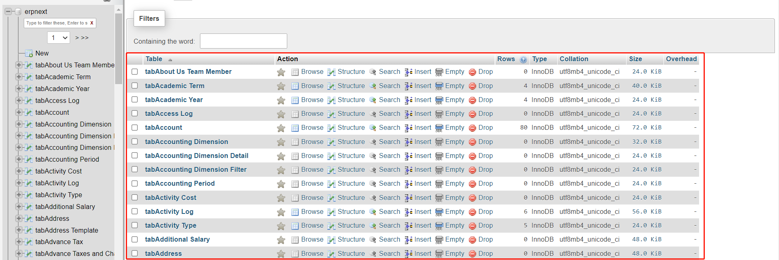

**4. Perform Common Functions in phpMyAdmin**

In the top menu, you’ll see various options for the database you’re working with, such as: Structure, SQL, Search, Query, Export, Import, Operations, Privileges, Routines, etc.

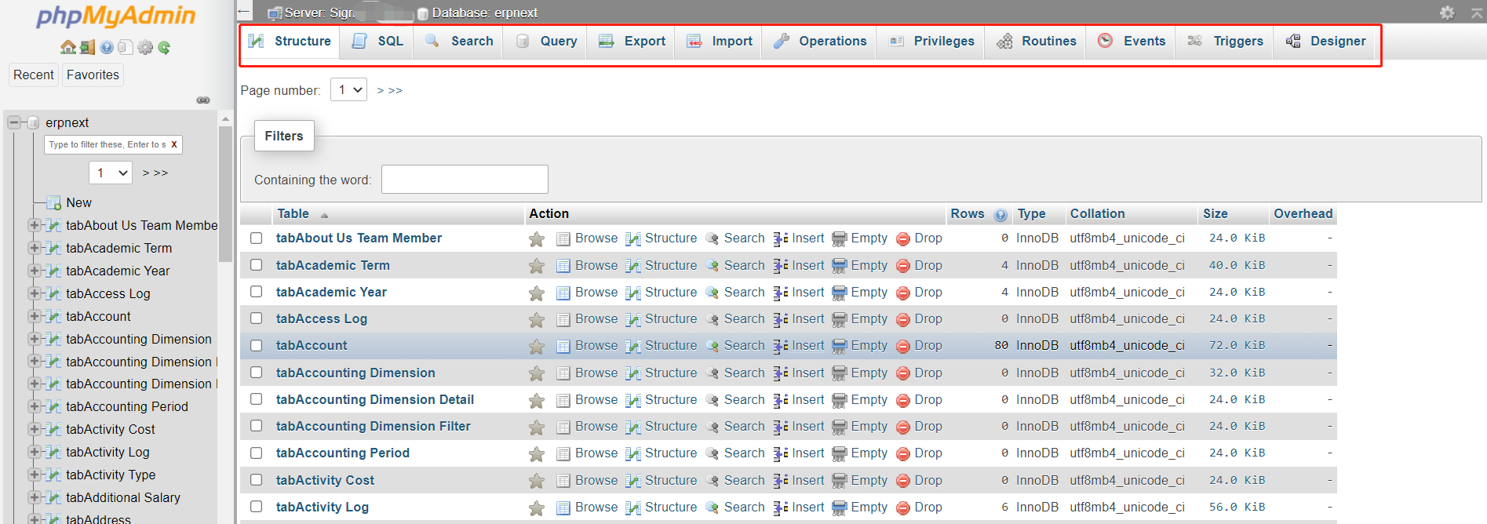

**Note:** when you import files using phpMyAdmin, the file size can not excess 100M.

**Cloud Clusters Control Panel Features**

**3. ERPNext Application Management**

**Checking the Resource Usage of Your ERPNext Package**

**Cloud Clusters has a monitoring console to collect and analyze the performance data, helping you effectively monitor and compare your sites performance over time. Whenever and wherever you are, follow the steps below, you will be available to keep track of the health of your application.**

**1. Locate your target deployment**

**Log in to the Control Panel and locate your target deployment on the Home page or the My Applications page.**



**2. Go to the Overview page**

**Click the "Manage" button on the Home page or the My Applications page to go to the Overview page.**

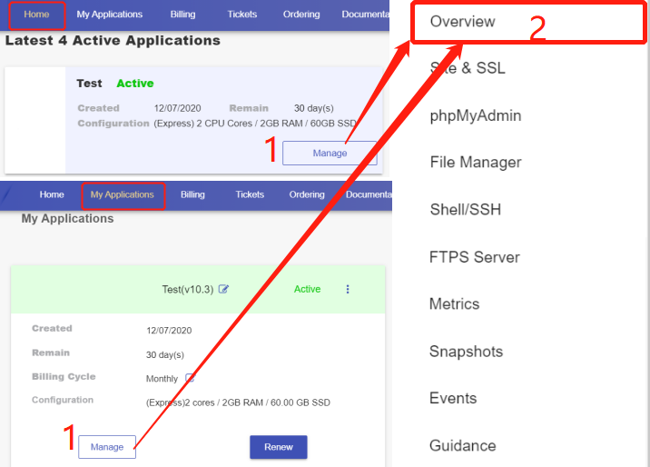

**3. Check the Real-Time status**

**The section shows each instance's status and resource usage, including RAM, Disk space, and backup disk space.**

**RAM: RAM is a short-term memory. It temporarily stores (remembers) everything currently running on an instance, like all OS-specific services and any web browser, image editor. If your RAM is full, the intance could be running slowly.**

**Disk Space: Disk Space is the maximum amount of data a disk, or drive is capable holding. A hard drive that's too full can slow down your instance, causing freezes and crashes.**

**Backup Disk space: Backup Disk Space is only used to store the snapshots files. When the space is full, the newly-generated backup files could not be stored.**

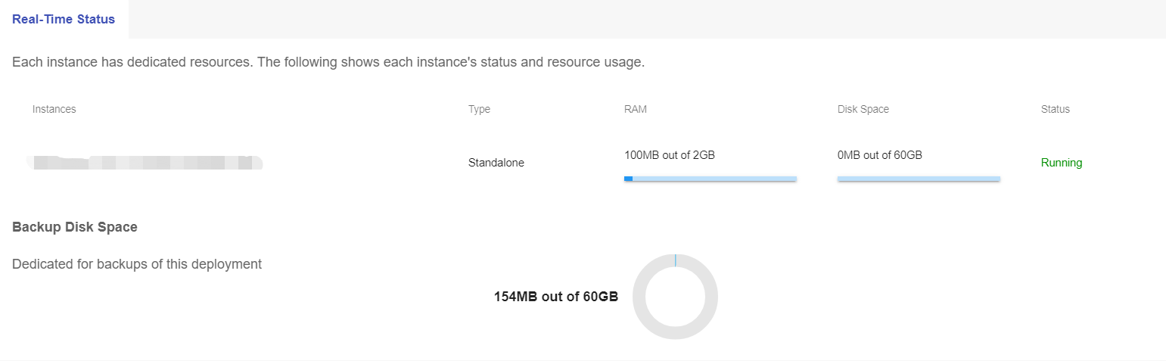

**4. Check the Metrics**

**Click the "Metrics" tab on the admin sidebar to check more details about the system-level performance metrics for your instance.**

**Select the time range to check the performance metrics during the period.**

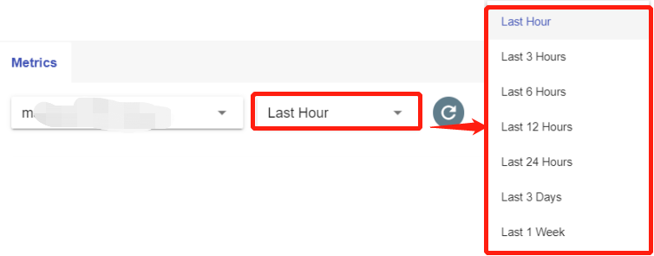

**CPU: The stats were showing the percentage of used CPU. The higher the CPU usage rate at the displayed timestamp, the busier the server is. If it is consistently above 80%, please consider increasing your CPU cores.**

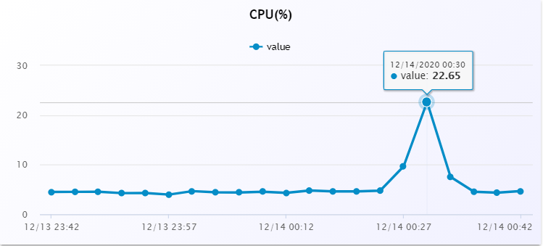

**Memory: The stats were showing the percentage of used RAM (Random Access Memory). The higher the Memory usage rate at the displayed timestamp, the slower the instance could be. If it is consistently above 80%, please consider increasing your RAM.**

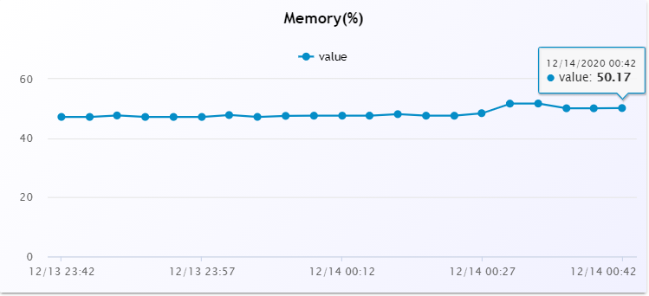

**Disk: The stats were showing the percentage of used Disk space. The higher the Disk space usage rate at the displayed timestamp, the slower the instance could be. If it is consistently above 80%, please consider increasing your Disk space.**

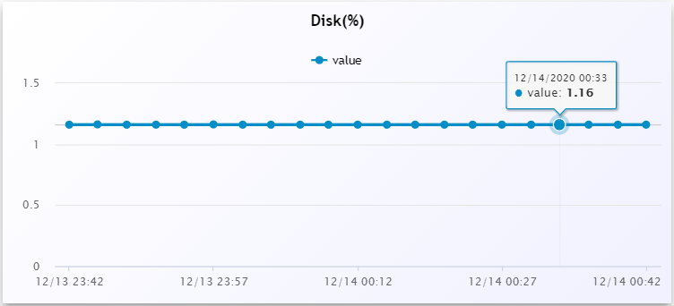

**Traffic: To measure bandwidth, the total amount of traffic sent and received across a specific period of time is counted. The blue line shows the transmitted bytes (KB/second) at the displayed timestamp; while the green one shows the received bytes (KB/second).**

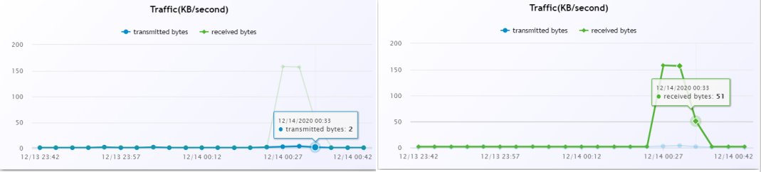

**phpMyAdmin**

**phpMyAdmin is one of the most popular web-based MySQL/MariaDB database management tools. It supports a wide range of operations like managing databases, relations, tables, columns, permissions and users. These operations can be performed via the user interface or by executing SQL statements.**

**Useful KB:**

[**How to Launch phpMyAdmin to Manage Your Database**](https://www.cloudclusters.io/docs/erpnext/Managing%20MySQL%20Database%20via%20phpMyAdmin1607996695.html)

**Please Note:**

* **The size of the imported file can not exceed 100MiB. If transferring a file over the size limit is needed, please use FTPS.**

**Web Shell / SSH**

**Shell/SSH is a web-based shell-like interface that enables remote access and management of an application by allowing the execution of arbitrary commands. You can issue commands to perform operations like monitoring, debugging, configuration parameters changing, etc.**

**Useful KB:**

[**Introduction to SSH and SSH Common Usage**](https://www.cloudclusters.io/docs/erpnext/SSH%20Introduction%20and%20Usage1607996637.html)[**How to Manage ERPNext via SSH**](https://www.cloudclusters.io/docs/erpnext/How%20to%20Use%20Web%20Shell1592899499.html)[**How to Reboot ERPNext Service**](https://www.cloudclusters.io/docs/erpnext/Rebooting%20ERPNext%20Service1607996762.html)

**Please Note:**

* **For the security purpose, only the account holders who pass the verification will be granted permission to web shell. Please**[**Update Billing information**](https://clients.cloudclusters.io/billing/billing-info)**to start the process.**
* **Only the settings related to your application will be permanently saved.**
* **Any abuse of the web shell service will result in the revocation of shell access.**

**Rebooting ERPNext Service**

**This article describes how you can reboot ERPNext service in the Control Panel.**

**1. Locate the target deployment**

**Log in to the Control Panel and locate your target deployment on the Home page or the My Applications page.**



**2. Navigate to the “Shell / SSH” page**

**Click the "Manage" button on the Home page or the My Applications page to go to the Shell / SSH page.**



**3. Reboot the service**

**Click the “Reboot” icon to reboot the service on the Shell / SSH page.**

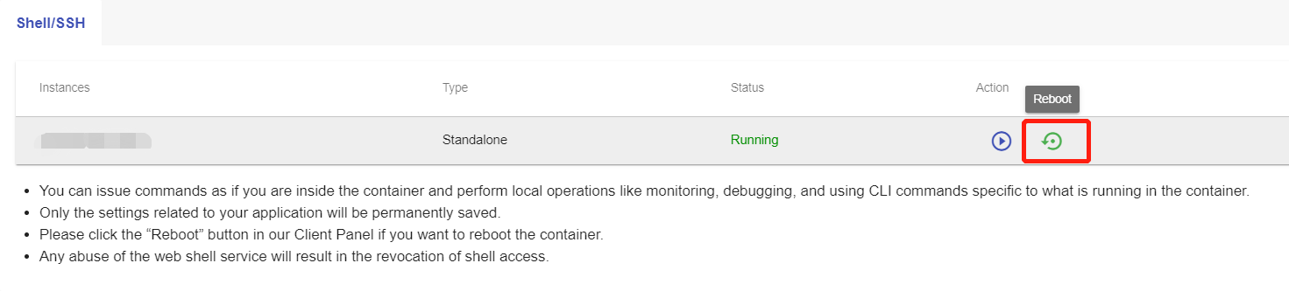

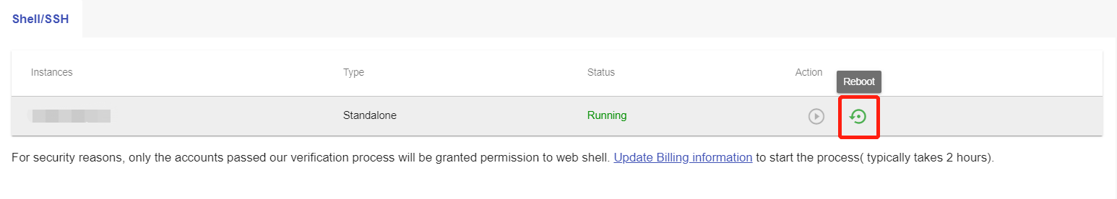

**Once the Reboot starts, the status will be changed to "startup". The Reboot process may take 1-3 minutes.**

**FTP Server**

**FTPS is an FTP(File Transfer Protocal) that uses the SSL(Secure Sockets Layer) protocol to encrypt data transfer over a network. You can start FTPS server to transfer your local data to your application.**

**Useful KB:**

[**How to Transfer Data Using FTPS**](https://www.cloudclusters.io/docs/erpnext/Transferring%20Data%20Using%20FTPS1607996718.html)

**Please Note:**

* **To transfer data between your application server and your local machine, you will need to have an FTP client(Filezilla or others) installed on your local machine.**
* **The FTPS server installation may take 2-3 minutes.**
* **The FTPS service will be automatically halted at the expiration time if no ongoing data transfer is detected.**
* **Please select the FTPES-FTP over Explicit TLS/SSL option as the server type.**

# Transferring Data Using FTPS

This article will explain how you can enable FTP server and use FTP client(Filezilla) to transfer files into FTP server in our cloud platform.

## 1. Locate the target deployment

Log in to the Control Panel and locate your target deployment on the **Home** page or the **My Applications** page.



## 2. Get FTP information

First, go to the FTPS page.

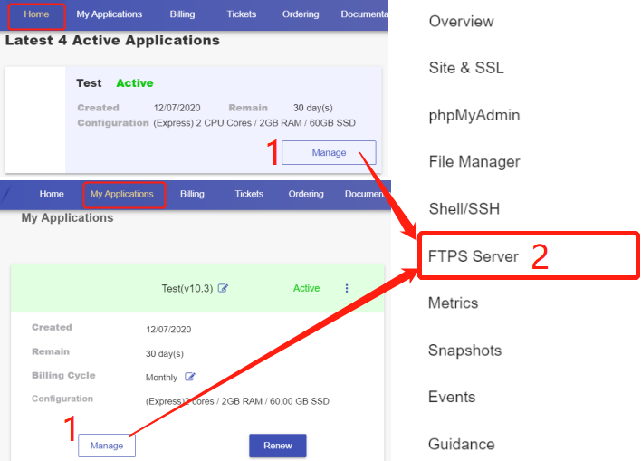

Then click the "Start" button to enable the FTPS feature.

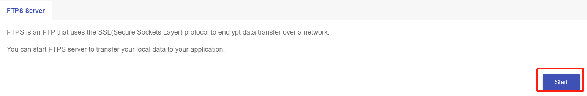

Get FTP information.

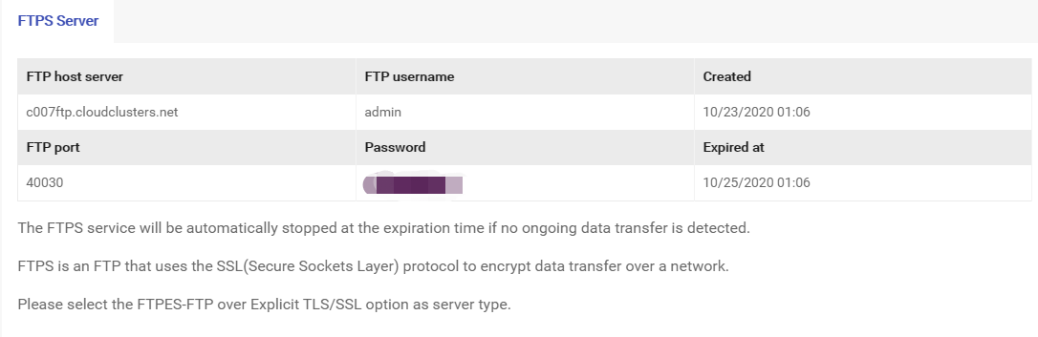

## 3. Connect to FTP server from your FTP client -- FileZilla

Please download [FileZilla](https://filezilla-project.org/download.php?platform=win64) if you have not installed it yet.

Open the Filezilla client and enter the FTP Server information, then click "connect".



**Site name:** Any name is OK

**Host:** the value under the "FTP host server" field

**Port:** the value under the "FTP port" field

**Encryption:** Require explicit FTP over TLS

**Logon Type:** Normal

**User:** the value under the "FTP username" field

**Password:** your password

**Transfer mode:** Passive

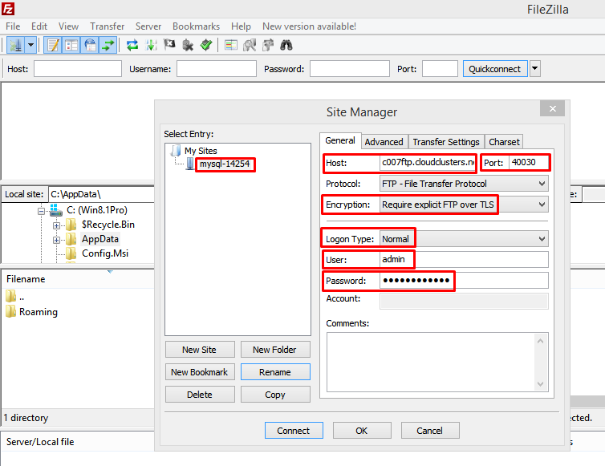

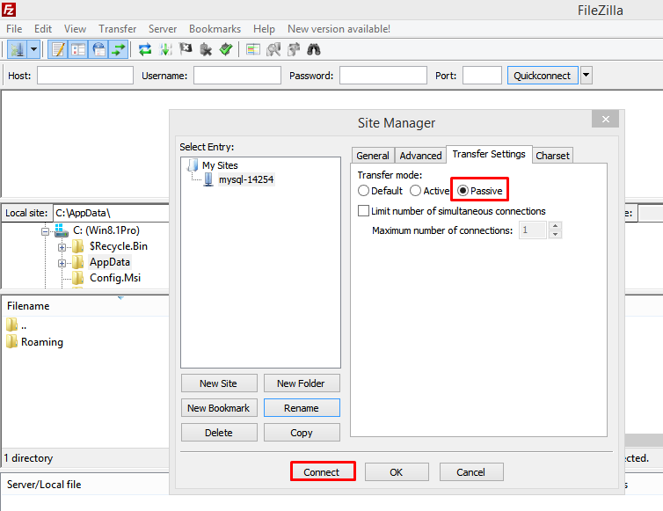

You've connected to the FTP server if you see the the folder list and "Directory listing successful" message.

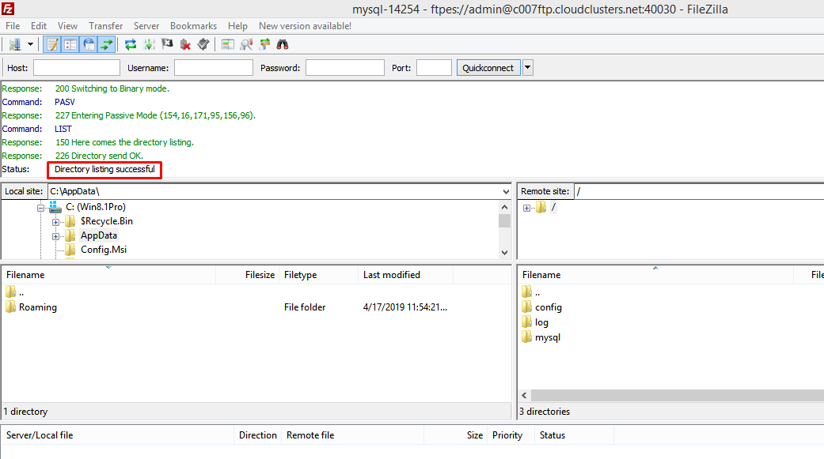

## 4. Transfer data into FTP server

### Upload your data into FTP server

Create a temp folder in FTP server to store data.

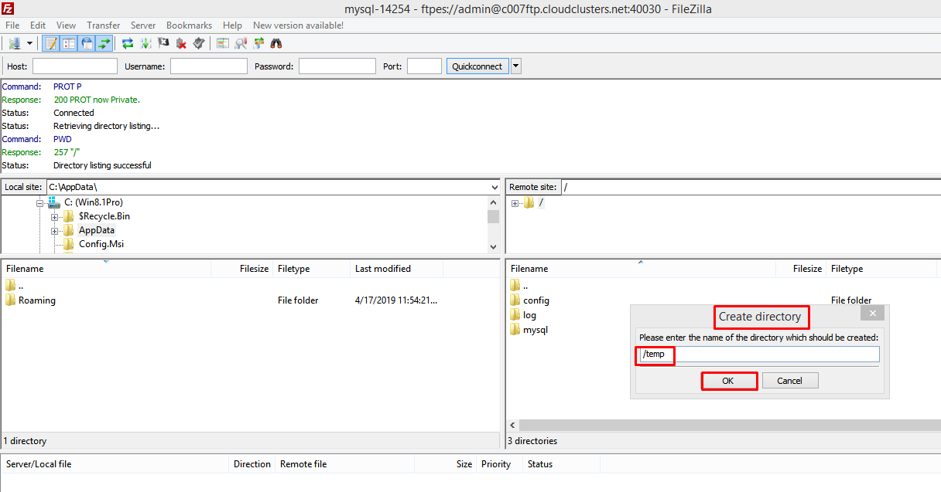

Click temp to go to the temp folder.

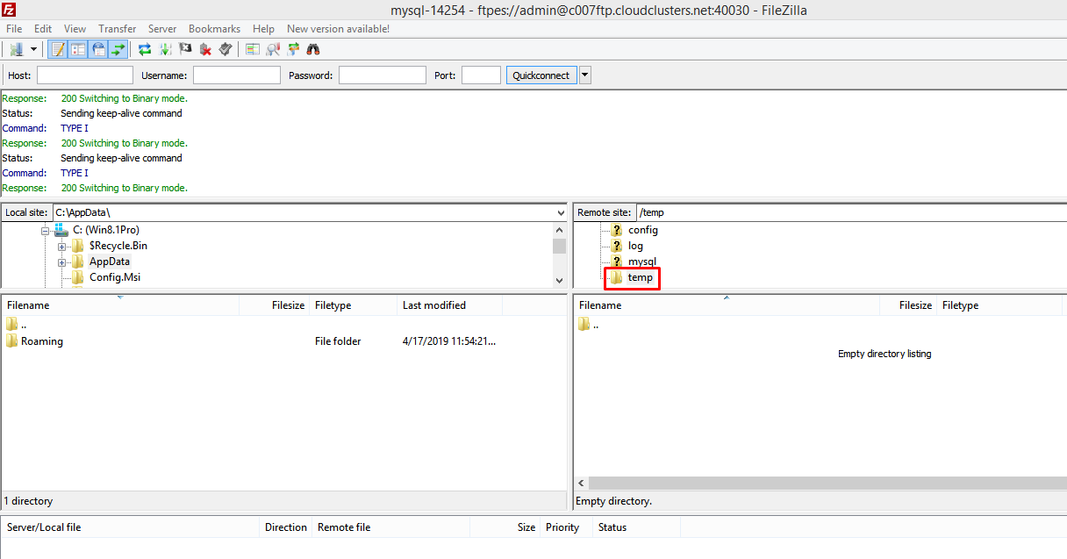

Choose the file at your local client then upload them to FTP server.

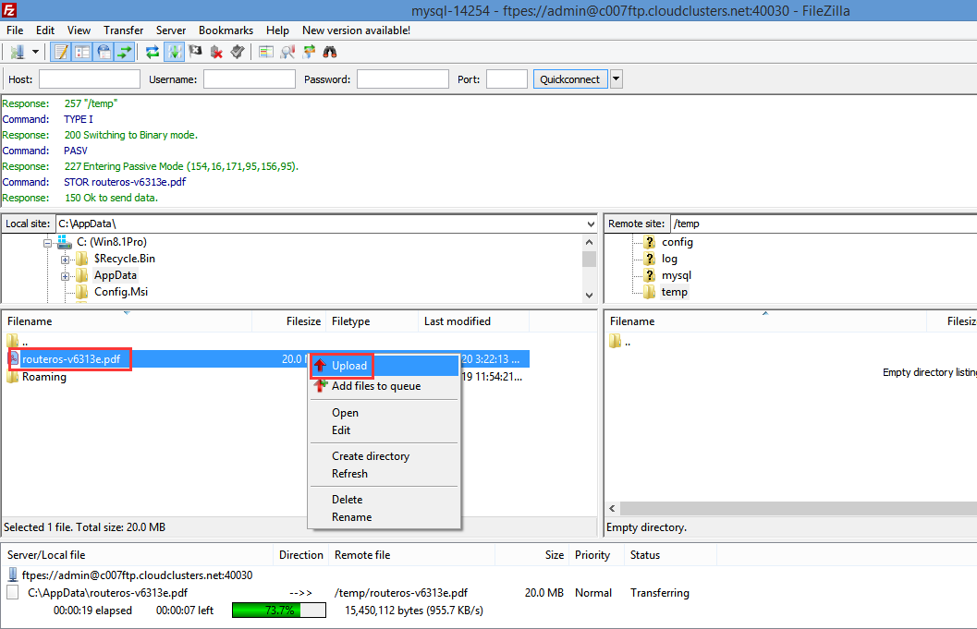

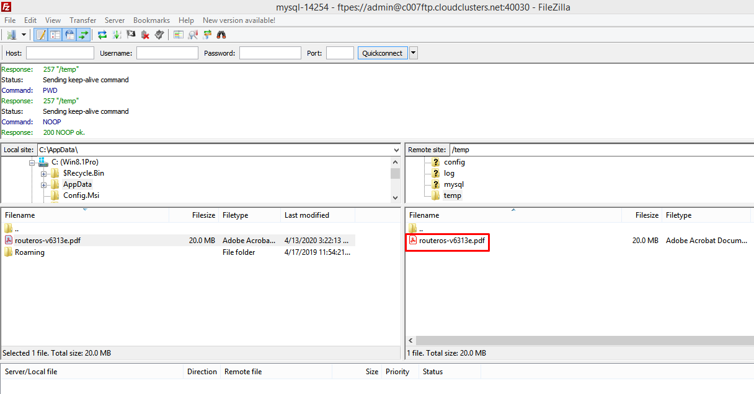

### Download your data to your local PC

1> locate the place you want to store your file on your local machine.

2> Locate the file you would like to download on your remote server. Right click the file, followed by choosing Download.

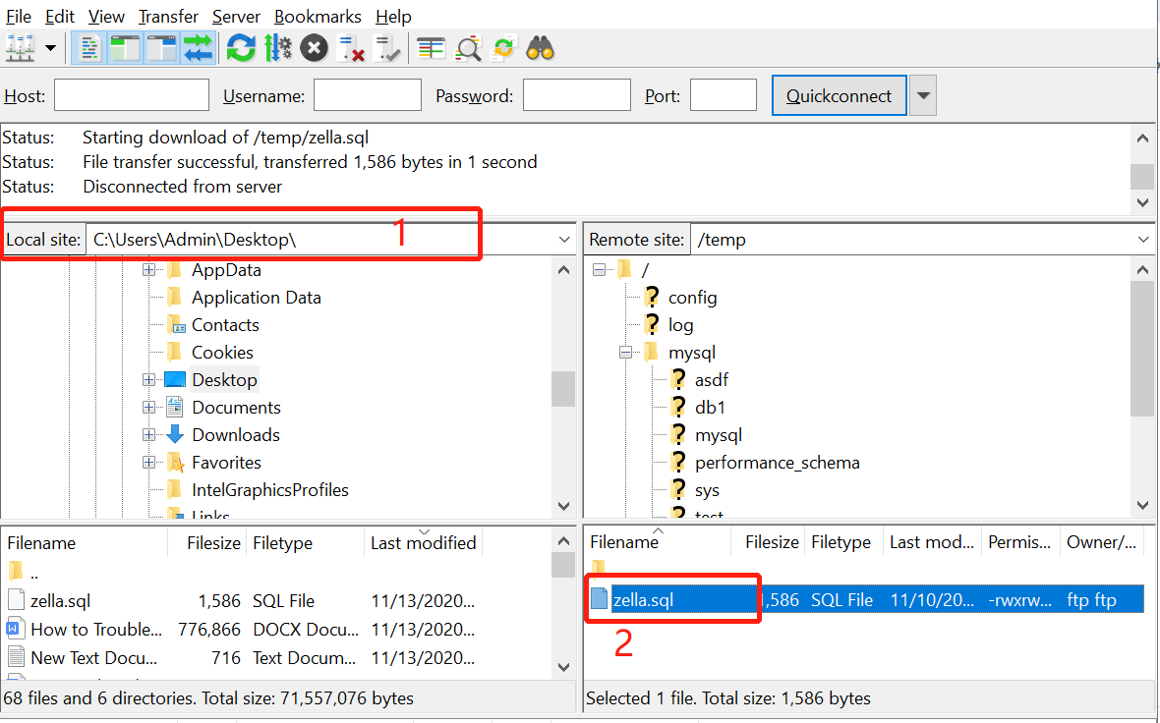

**File Manager**

**File Manager is a web-based computer program that provides a user interface to manage files and folders. It displays the hierarchical structure of folders and files in your project. File manager allows you to edit, delete, upload, download, zip, copy and paste files and folders directly from the interface.**

**Useful KB:**

[**How to Manage Website Files Using File Manager**](https://www.cloudclusters.io/docs/erpnext/Manage%20ERPNext1599121375.html)

**Initializing the ERPNext Application**

**The Initialization process allows you to reinstall you ERPNext application to the current version or a different version that Cloud Clusters provides. The article describes how you can perform the operation.**

**Important The operation will erase all data of the application. Please make sure you have a backup of your data on your local machine. To make a system backup, please refer to the documentation.**

**1. Locate target application**

**Log in to the Control Panel and locate your target deployment on the Home page or the My Applications page.**



**2. Go to the Overview page**

**Click the "Manage" button on the Home page or the My Applications page to go to the Overview page.**



**3. Reinstall your ERPNext**

**Then scroll down to the "Reinstallation" section. You will see the "Install" button.**

1. **Click the "Install" button.**
2. **select Reinstall with current version or Reinstall with a different version.**
3. **Submit your request.**

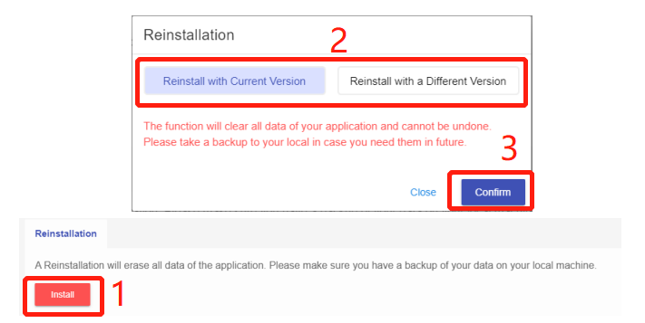

**There typically will be 1-3 minutes downtime during the re-installation process**

**ERPNext Website Monitoring Console**

**Cloud Clusters has a monitoring console to collect and analyze the performance data, helping you effectively monitor and compare your sites performance over time. Whenever and wherever you are, follow the steps below, you will be available to keep track of the health of your application.**

**1. Locate your target deployment**

**Log in to the Control Panel and locate your target deployment on the Home page or the My Applications page.**

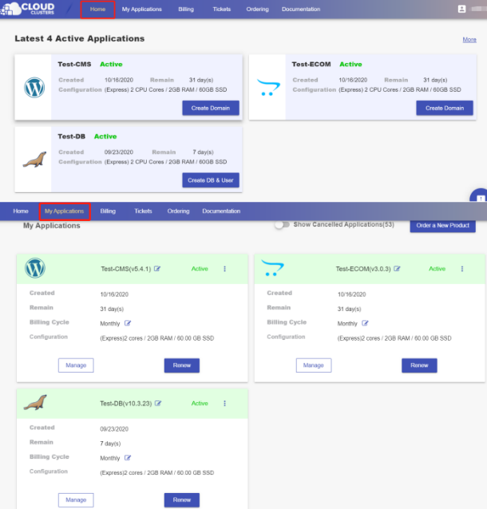

**2. Navigate to the Metrics page**

**Click the "Manage" button on the Home page or the My Applications page. Then Click the Metrics tab in the menu bar.**

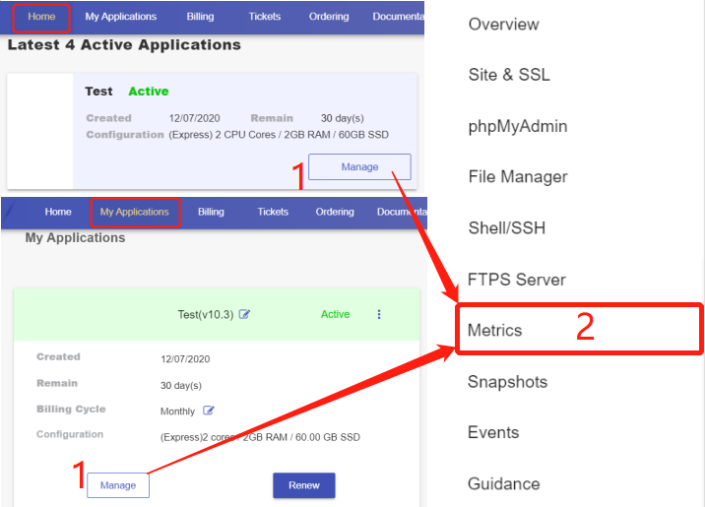

**3. Monitor your website performance**

**On the "Metrics" page, choose the nodename and time range from the drop-down boxes below, then you will get your performance graphs in minutes. If you would like to refresh the data, simply click on the refresh icon on the right.**

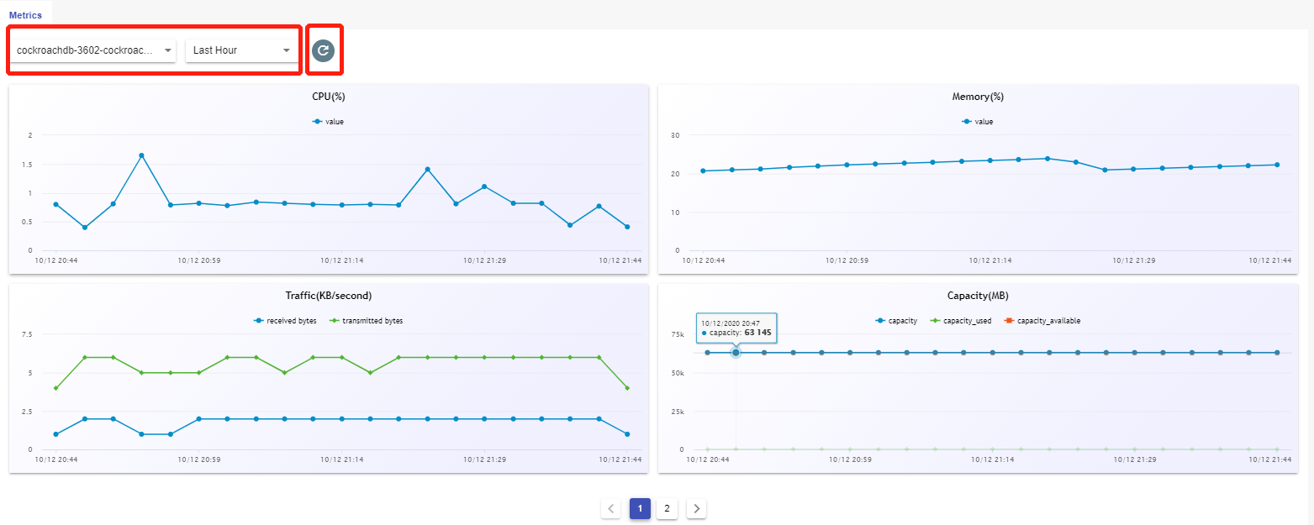

**Activity Log**

**Sometimes it happens that you need to go back to review what you did. When it comes, Events is right here waiting for your visit, recording and reappearing your track. To find out how to access the log, please follow the steps below:**

**1. Locate your target deployment**

**Log in to the Control Panel and locate your target deployment on the Home page or the My Applications page.**

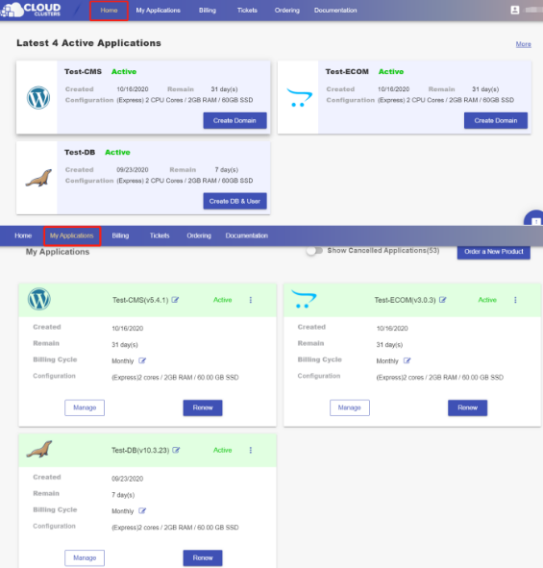

**2. Navigate to the Events page**

**Click the "Manage" button on the Home page or the My Applications page. Then Click the Events tab in the menu bar.**

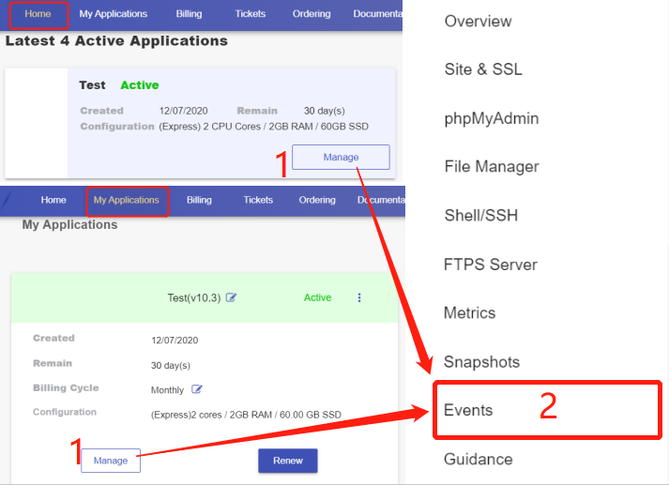

**3. Review previous activities**

**On the "EVENTS" page, you will find your operation history clearly recorded.**

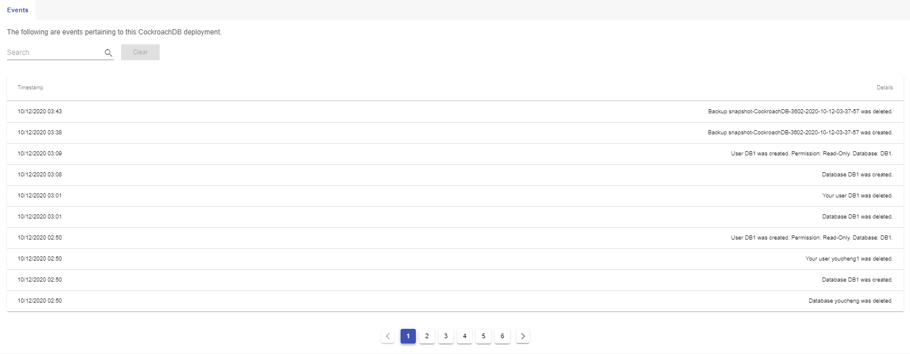

**4. Search for previous activities**

**Input keywords in the search area, then click the search icon next to it. The items that contains the keywords will show.**

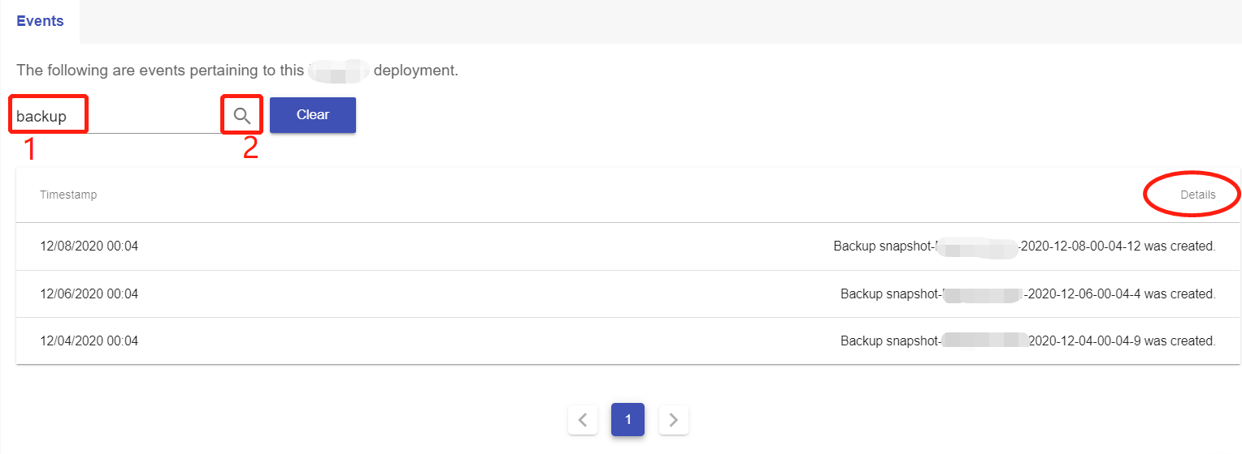

**Backups and Restoration for ERPNext**

**Backup and Restoration Overview**

**Backups**

**Cloud Clusters backups are point-in-time filesystem-level snapshots. Snapshots are an instantaneous "picture" of your server's file system at a certain period of time. This picture captures the entire file system as it was when the snapshot is taken. When a snapshot is used to restore the server, the server will revert to exactly how it was at the time of the snapshot.**

**Cloud Clusters automates the process of backing up your ERPNext. The backup frequency vary based on the plan and we practice different types of snapshots. Regarding our backup strategy, you should know the following things:**

**Type of Snapshot:**

* ***A full snapshot* holds a full copy of the cluster data at a given point of time. By default, data of all the caches will be stored in a snapshot.**
* ***An incremental snapshot* is a copy of the data that contains only that portion that has changed since the preceding full or incremental snapshot copy. When a full recovery is needed, the restoration process needs the last full snapshot, plus all the incremental snapshots up to the point of restoration.**

**Scheduled Backup**

| **plan** | **Backup Frequency** | **Backup Day** | **Types of Backup** |
| --- | --- | --- | --- |
| Express | Weekly | Sunday | 1 full snapshot |
| Basic | Twice per Week | Wednesday,Saturday | 1 full snapshot +1 incremental snapshot |
| Professional | Three times per week | Tuesday,Thursday,Saturday | 1 full snapshot + 2 incremental snapshots |
| Advanced | Daily | everyday | 1 full snapshot + 6 incremental snapshots |

**On-demand backup**

**Besides scheduled backups, we also support on-demand backups. If you need to take a full system snapshot manually, please see**[**taking a system snapshot**](https://www.cloudclusters.io/docs/erpnext/Backup%20and%20Restoration1553233924.html)**. Each backup file will be restored for 7 days on our platform. If you’d like to save it for a longer time, you can download it to your local machine.**

**Restoration**

**You can restore your ERPNext to the state that the selected snapshot captured. The Restoration can be easily taken in our Control Panel. If you need help on the operation, please take a look at**[**restoring a system backup**](https://www.cloudclusters.io/docs/erpnext/Restoring%20a%20System%20Backup1596177897.html)**.**

**How to Take a System Backup**

**Regular backups are automatically taken on our plarform. This article will explain how you can take a backup manually.**

**1. Locate the target deployment**

**Log in to the Control Panel and locate your target deployment on the Home page or the My Applications page.**



**2. Navigate to the Snapshots page**

**Click the "Manage" button on the Home page or the My Applications pgae, followed by the “Snapshots” tab. You will be shown a list of backup files. A “TAKE SNAPSHOT” button on the buttom allows you to manually back up your data, which will be a system-level backup.**

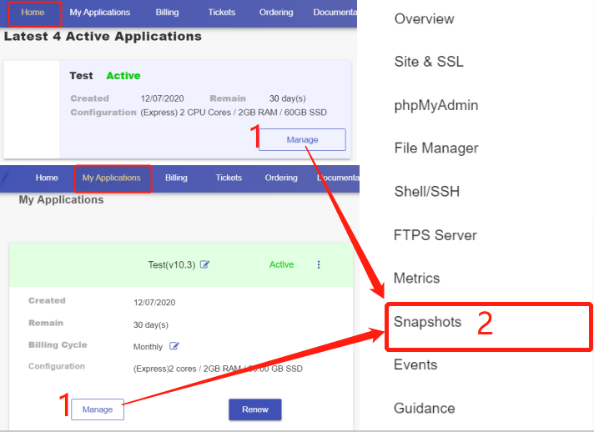

**3. Back up your data**

**Click "TAKE SNAPSHOT". A confirmation box will pop up. You are free to rename the backup. Click on "SAVE" to start the backup process. You can get your backup in seconds after that.**

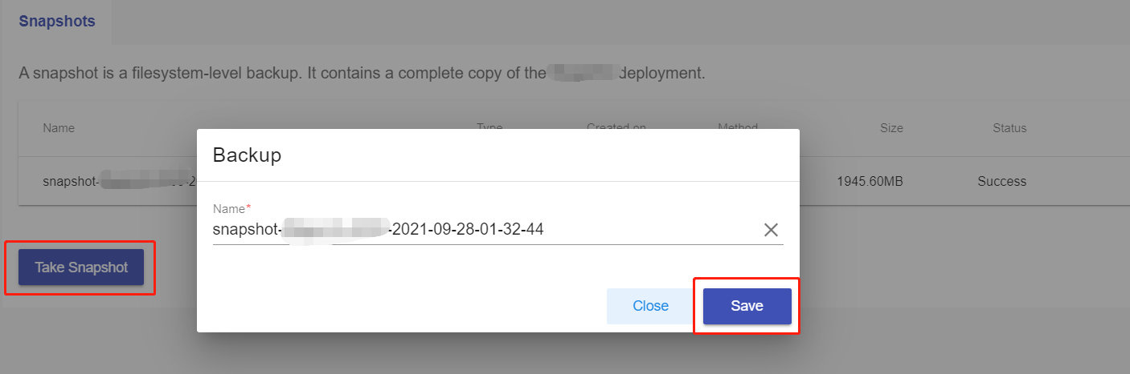

**4. Export your backup**

**Click the three-dot icon at the end of the backup file you want to export. Then click "Export".**

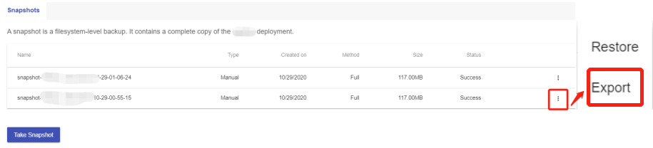

**Your backup will be transferred to a file server. It may take 15-30 minutes. Once the backup is transferred, there are two options for you to get what you want:**

**Option 1: come back to control panel to download your backup. Please repeat the steps described above to get your files under the Snapshots. Click the download icon at the end of the backup file to get the backup.**

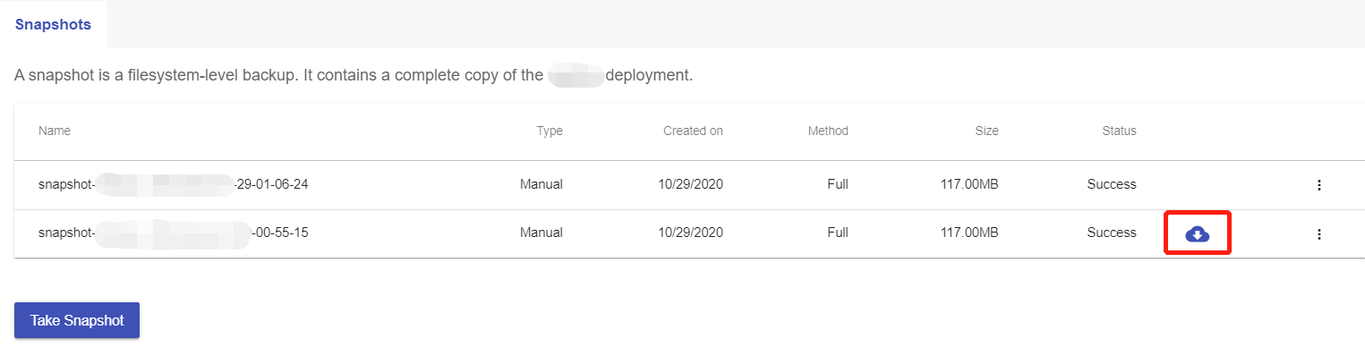

**Option 2: get the backup through the download link via an email from us.**

**How to Restore a System Backup**

**This guide article will show you how to restore a backup.**

**1. Locate your target deployment**

**Log in to the Control Panel and locate your target deployment on the Home page or the My Applications page.**

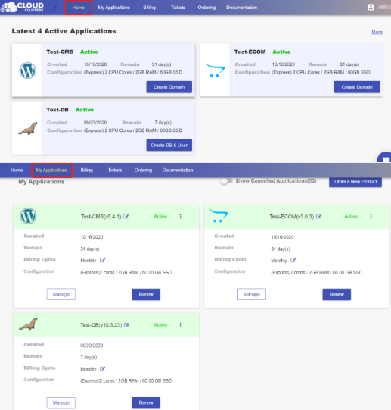

**2. Navigate to the Snapshots page**

**Click the "Manage" button on the Home page or the My Applications pgae, followed by the “Snapshots” tab. You will be shown a list of backup files.**



**3. Restore your data**

**Locate the backup you would like to restore your data from. Click the “Restore” icon at the end of the backup file and a confirmation box will pop up. Click "CONFIRM" to start the process. It will not take you long to finish the restoration.**

